***Early Prediction Of Low Birth Weight Cases(LBW) Using Machine Learning***

Karri Hema Harshitha

*Computer Science and Engineering Shri Vishnu Engineering College for Women(A)*

Bhimavaram, Andhra Pradesh hemaharshitha333[@gmail.com](mailto:keerthibalathotisvecw@gmail.com)

Nandikam Lakshmi Sai Akhila

*Computer Science and Engineering Shri Vishnu Engineering College for Women(A)*

Bhimavaram, Andhra Pradesh akhila.nls2001@gmail.com

Komali Arthi

*Computer Science and Engineering Shri Vishnu Engineering College for Women(A)*

Bhimavaram, Andhra Pradesh

aarthikomali[@gmail.com](mailto:keerthibalathotisvecw@gmail.com)

Nariboina Vanaja

*Computer Science and Engineering Shri Vishnu Engineering College for Women(A)*

Bhimavaram, Andhra Pradesh vanajasvt789[@gmail.com](mailto:hunnypriyankacse@gmail.com)

Mudunuri Tulasi Lakshmi

*Computer Science and Engineering Shri Vishnu Engineering College for Women(A)*

Bhimavaram, Andhra Pradesh tulasilakshmimudunuri[@gmail.com](mailto:indugamellihimasri6575@gmail.com)

Kanumuri Ratna Kumari (M.Tech)

Assistant Professor

*Computer Science and Engineering*

*Shri Vishnu Engineering College for*

*Women(A)*

Bhimavaram,Andhra Pradesh

Kratnacse@svecw.edu.in

***Abstract- Low Birth weight (LBW) acts as an indicator of sickness in newborn babies. LBW is closely associated with infant mortality as well as various health outcomes later in life. Various studies show a strong correlation between maternal health during pregnancy and the child’s birth weight. This manuscript exploits machine learning techniques to gain useful information from health indicators of pregnant women for early detection of potential LBW cases. The forecasting problem has been reformulated as a classiﬁcation problem between LBW and NOT-LBW classes using supervised Machine learning for LBW detection as a binary machine classiﬁcation problem. Expectedly, the proposed model achieved better accuracy. Indian healthcare data was used to construct decision rules to be extrapolated to predictive healthcare in smart cities. A screening tool based on the decision model is developed to assist healthcare professionals in Obstetrics and Gynecology (OBG).***

***Keywords— Low Birth weight (LBW), Smart health informatics, Predictive Analytics, Machine Learning (ML).***

1. **INTRODUCTION**

World Health Organization Maternal Health and Safe Motherhood Programme-1992, Low Birth Weight. It is expected to rise at the rate of 12% every year. Nearly 39% of power is used for cooling 45% for running the Information Technology (IT), infrastructure, and 13% for lights.

This level of consumption costs heavily to businesses. LBW and prematurity remain a serious public health burden worldwide. Neonatal deaths account for a major fraction of deaths of children under the age of five, globally Children with LBW are at significantly higher risks of early childhood morbidity and mortality when compared with their counterparts with normal birth weights.

Low birth weight is the term used to refer to babies born with a weight less than 2500gm Low birth weight (LBW) has been identiﬁed as a major public health problem around the world. LBW includes both pre-term babies as well as fully grown babies who are very small in size because of intrauterine growth retardation. Birth weight is closely associated with neonatal and infant mortality, mortality rates being signiﬁcantly higher in LBW babies when compared to normal birth weight (NBW) babies. This phenomenon is now of global concern in the view of serious short-term and long-term problems such as developmental disorders, neurosensory outcomes, and health outcomes including Type 2 diabetes, cerebral stroke, hypertension, and various other disorders that LBW babies are prone to.

This is a major problem in developing countries, especially in India which contributes to about 30 percent of the global LBW cases.

Innumerable studies around the world indicate a strong between maternal health and the impact on the birth weight of babies. Popular assumptions claim that LBW can be considerably reduced, with dedicated medical care during pregnancy.

In our approach, the risk factors in pregnant women that can be easily assessed with basic methods are carefully examined throughout the gestation period and form the basis for predictions.

Early detection can help in preventing the chances of LBW and put forward some recommendations under some intervention mechanisms.

1. **LITERATURE SURVEY**

[1] World Health Organization-1992, International statistical classiﬁcation of diseases and related health problems, Tenth revision, Geneva, World Health Organization.

[2] Kramer MS. Determinants of low birth weight: methodological assessment and meta-analysis. Bull World Health Organ. 1987; 65(5):663-737. PMID: 3322602; PMCID: PMC2491072.

1. **SYSTEM DESIGN**

The system design largely depends on the objectives and

goals of the system.

# Objectives:

* + Accurate Prediction System using machine learning mainly deals with the results of how a baby is born i.e. either low birth weight or not.

1. **IMPLEMENTATION**

Phases of implementation:

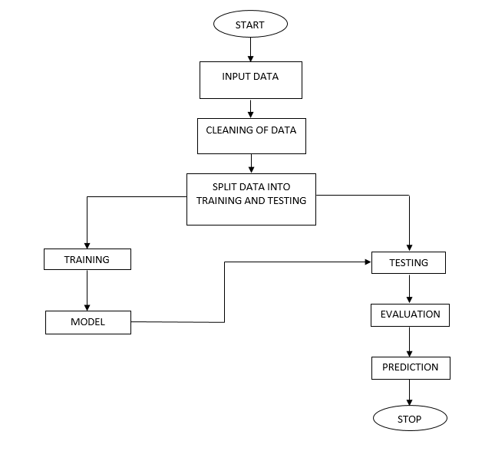

.

**Data Collection:** Data collection is the procedure of collecting, measuring, and analyzing accurate insights for research using standard validated techniques.

**Input Data:** We have taken a dataset as the input which contains various parameters that cause low birth weight for infants.

**Data Cleaning:** In this process, we have fixed or removed incorrect, corrupted, incorrectly formatted, duplicate, or incomplete data within a dataset. When combining multiple data sources, there are many opportunities for data to be duplicated or mislabeled. If data is incorrect, outcomes and algorithms are unreliable, even though they may look correct. So, data cleaning is an important step.

**Splitting the Data:** We have split the dataset into train and test sets to evaluate how well our machine learning model performs. The train set is used to fit the model, and the statistics of the train set are known. The second set is called the test data set, this set is solely used for predictions.

**Training and Testing the Data:** Training and Testing are done to measure the accuracy of our model.

The training dataset is used to fit the model, and the test dataset is used to evaluate the model.

**Evaluation:** It is done to know how well is my model doing. Will training my model on more data improve its performance? And Do I need to include more features?

**Prediction:** This involves certain manipulations of data from existing data sets with the goal of identifying some new trends and patterns. These trends and patterns are then used to predict future outcomes and trends regarding whether the baby will be born with a low weight or not. INTERMEDIATE RESULTS:

Home Page:

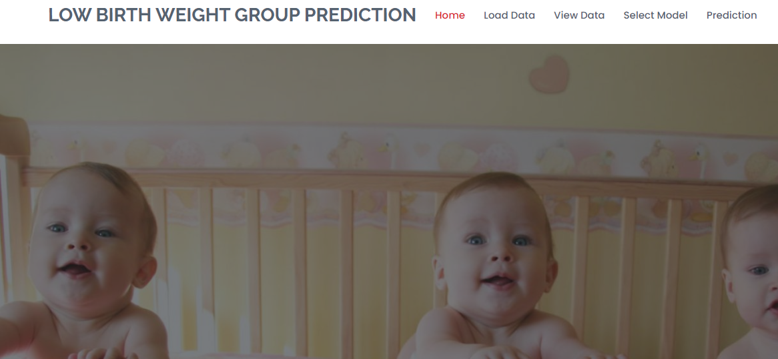

Load Data page:

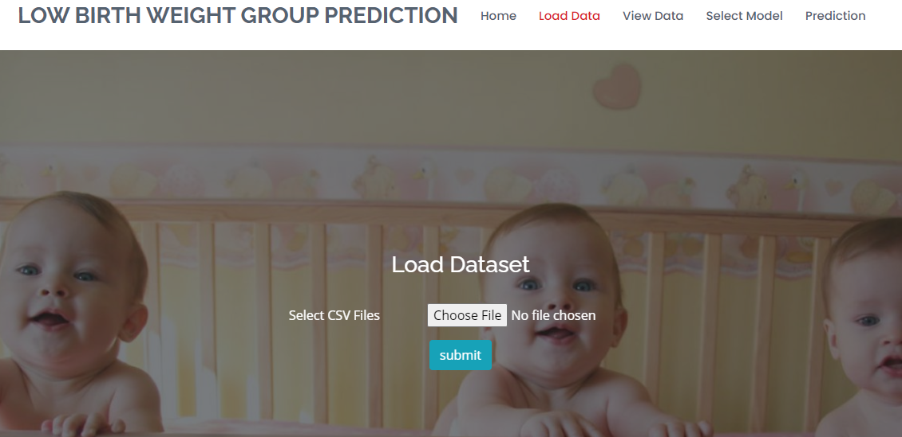

View Data Page: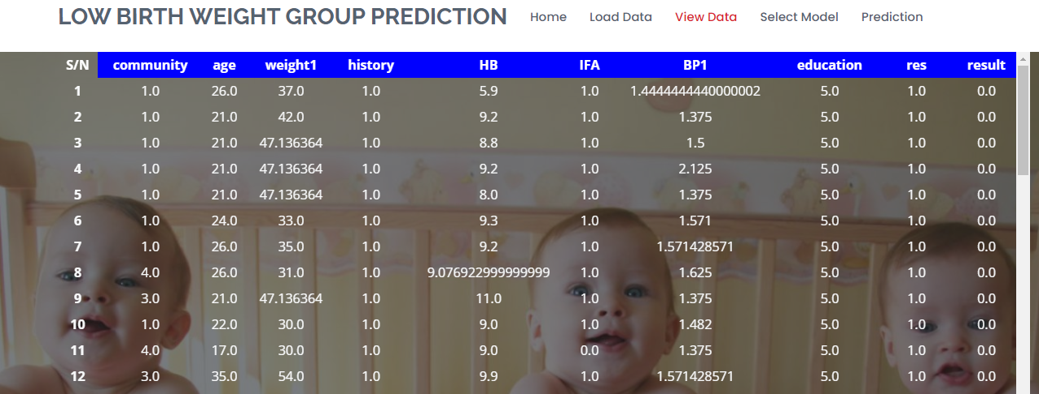

Model Selection Page: 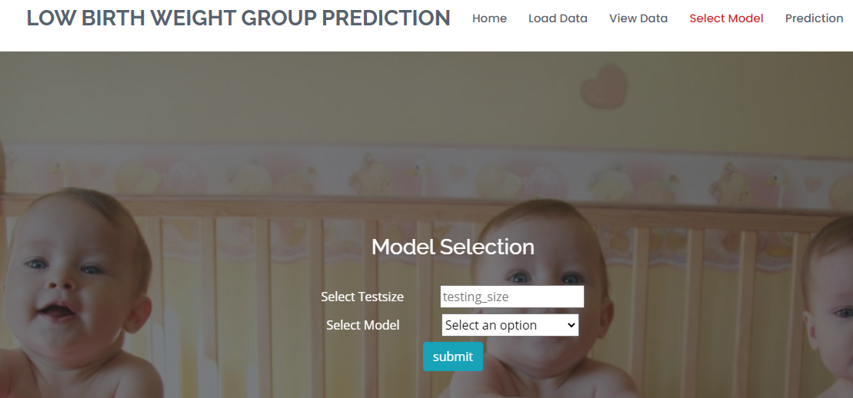

Prediction Page: 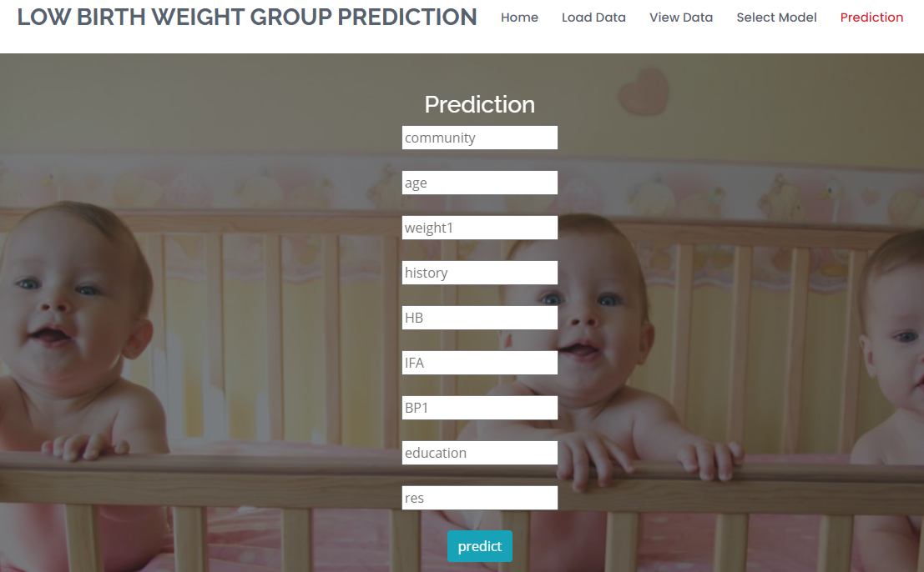

# RESULTS

We can finally get the result as a baby belonging or not belonging to LBW case by the input values given by the user.

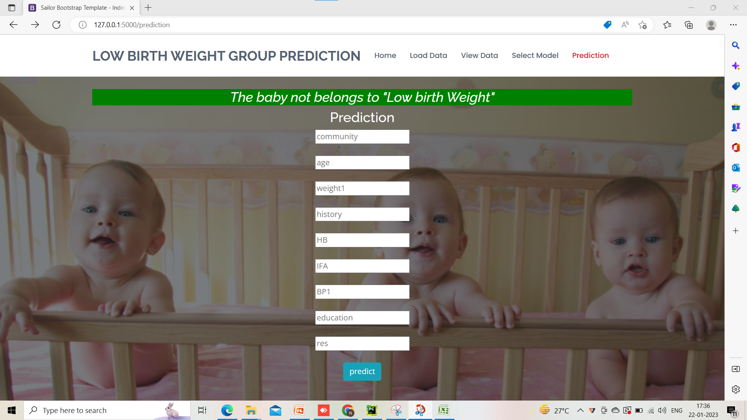

# C:\Users\WINDOWS\Desktop\Screenshot 2023-01-22 172241.pngVI. CONCLUSION

In this application, we have successfully created a machine learning model to estimate whether the baby belongs to the Low Birth Weight or not belongs to the Low Birth. This is developed in a user-friendly environment using Flask via Python programming. We noticed that out of XGBoost Classifier, Random Forest, Decision Tree, and Support Vector Classifier. Decision Tree Classifier performs well with better accuracy.

**VII. REFERENCES**

[1] <https://en.wikipedia.org/wiki/Low_birth_weight>

[2] United Nations Children’s Fund and World Health Organization 2004, Low Birth Weight: Country, regional and global estimates, New York, UNICEF.